
The Islamia University of Bahawalpur

Review Article | Research Methods
Explainable Identification of Human vs. Large Language Model (LLM) Generated Text: A Systematic Review
By: Jawwad Ahmad | F25NDOCS3W04013 | MSCS 2nd

Supervisor

Dr. Ahmad Niaz
Assistant Professor, Computer Science Department

Abstract
The rapid proliferation of Large Language Models (LLMs) such as GPT-4, Llama, Claude, and Google Gemini has intensified the need for reliable automated detection of machine-generated text across high-stakes domains including academia, journalism, and medicine. While transformer-based detection systems have achieved state-of-the-art classification accuracy, their opaque decision-making processes undermine user trust and institutional accountability — a critical limitation in settings where the consequences of misclassification are significant. This review addresses that limitation by systematically examining the intersection of AI-generated text detection and Explainable Artificial Intelligence (XAI), with particular focus on the post-hoc local explanation methods LIME (Local Interpretable Model-agnostic Explanations) and SHAP (SHapley Additive exPlanations).
Following the PRISMA framework, a systematic search of four electronic databases yielded twelve studies published between 2023 and 2026 that met pre-specified inclusion criteria. Findings are synthesized across three thematic clusters — stylometric and classical machine learning approaches, transformer-based deep learning methods, and multi-label attribution frameworks — and analyzed against four research questions addressing detection accuracy, XAI effectiveness, cross-domain generalizability, and structural limitations.
The review's principal positive finding is convergent validity across methods: LIME and SHAP consistently identify grammatical standardization, formulaic transitional language, low lexical entropy, and suppressed epistemic hedging as the most discriminative markers of LLM authorship, regardless of the underlying detection architecture. Critically, the review also documents an unresolved adversarial paradox — XAI explanations that make detection transparent simultaneously enable targeted evasion — and identifies five structural research gaps spanning adversarial robustness, XAI evaluation standards, fairness for non-native writers, cross-domain generalization, and multilingual coverage. The findings provide a consolidated, evidence-based reference for researchers, developers, and practitioners working toward detection systems that are not only accurate, but interpretable, equitable, and trustworthy.

Keywords: AI-generated text detection, explainable artificial intelligence, LIME, SHAP, large language models, stylometry, transformer models, natural language processing, systematic literature review

Table of Contents
Executive Summary i
1. Introduction 3
2. Background/Literature Review 3
Literature Review - Comparative Table 5
3. Problem Statement 7
4. Objectives 7
5. Research Questions 8
6. Scope 8
7. Methodology for the Review 9
8. Significance 10
9. Conclusion 10
10. References 12

1. Introduction
The emergence of Large Language Models (LLMs) such as GPT-4, Llama, Claude, and Google Gemini has fundamentally redefined the boundaries of automated text generation. These systems produce output that is grammatically fluent, contextually coherent, and stylistically indistinguishable from human prose — a capability that, while remarkable, introduces a spectrum of risks that society is only beginning to grapple with. In academic settings, LLM-generated submissions undermine the integrity of assessment. In journalism, synthetic content erodes public trust in information. In legal and medical contexts, machine-generated text without clear attribution carries serious ethical and institutional consequences. As a result, the automated detection of AI-generated text has emerged as one of the most pressing research challenges in contemporary Natural Language Processing (NLP).
Early detection systems drew upon traditional machine learning techniques — employing features such as perplexity scores, burstiness metrics, and stylometric indices to distinguish human from machine authorship. While these approaches established a foundational vocabulary for the problem, they were rapidly eclipsed by transformer-based architectures such as RoBERTa and DistilBERT, which achieved significantly higher classification accuracy by learning rich, contextual representations directly from text. The HULLMI framework (Joshi et al., 2024), for instance, demonstrated that fine-tuned transformer models could outperform conventional classifiers across multiple LLM sources and text domains. However, improved accuracy alone has not resolved the underlying challenge — it has in many ways compounded it.
The central limitation of modern detection systems is their opacity. Transformer-based detectors operate as "black boxes," arriving at classification decisions through internal representations that are neither visible nor interpretable to end-users. This poses a critical problem in high-stakes environments: an educator cannot discipline a student, a journal cannot reject a manuscript, and a legal body cannot challenge evidence on the basis of a system whose reasoning is inaccessible. Accuracy without accountability is insufficient. The field has therefore begun to turn toward Explainable Artificial Intelligence (XAI) as an essential complement to detection performance.
Among the interpretability frameworks that have gained traction in this domain, two post-hoc local explanation methods stand out as the most widely adopted: LIME (Local Interpretable Model-agnostic Explanations) and SHAP (SHapley Additive exPlanations). Both methods are model-agnostic — applicable across traditional machine learning and deep learning architectures alike — and both provide feature-level attribution, enabling users to understand which specific linguistic properties drove a classification decision. Studies such as Aditya Shah et al. (2023) and Masih et al. (2025) have demonstrated that LIME and SHAP can surface meaningful patterns — including grammatical standardization, atypical word frequency distributions, and punctuation anomalies — that consistently distinguish AI-generated text from human writing. Critically, these insights extend beyond individual predictions: as Najjar et al. (2025) showed, XAI feature profiles can even be used to attribute text to specific LLMs, moving the field from binary classification toward a richer multi-label attribution paradigm.
Despite this progress, the literature remains fragmented. Studies differ in the detection architectures they employ, the datasets they evaluate on, the explainability methods they apply, and the domains they target. No comprehensive synthesis currently exists that maps the full landscape of explainable AI-generated text detection across multiple LLMs, text domains, sample lengths, and XAI methodologies. This gap leaves researchers, educators, and policymakers without a unified, evidence-based reference — and it leaves open significant questions about adversarial robustness (Mohammadi et al., 2025), cross-domain generalizability, and the fairness implications of systems that may penalize non-native English speakers whose fluent prose stylistically resembles LLM output.
This paper addresses that gap through a Systematic Literature Review (SLR) guided by the PRISMA framework, synthesizing research published between 2023 and 2026 — a window selected to capture the post-ChatGPT era of both generative AI development and detection scholarship. The review is organized around three thematic clusters that emerge from the literature: stylometric and classical machine learning approaches, transformer-based deep learning methods, and multi-label attribution frameworks. Across all three, the role of XAI — particularly LIME and SHAP — is examined not merely as a transparency add-on, but as a core analytical tool that advances both interpretability and scientific understanding of how LLMs generate text.
The remainder of this paper is structured as follows. Section 2 provides foundational background on LLMs, AI-generated text detection, and XAI methods. Section 3 describes the systematic review methodology. Section 4 presents the thematic literature synthesis. Section 5 offers a comparative analysis across detection paradigms. Section 6 identifies research gaps and future directions. Section 7 concludes the review.
Motivation landscape of this review
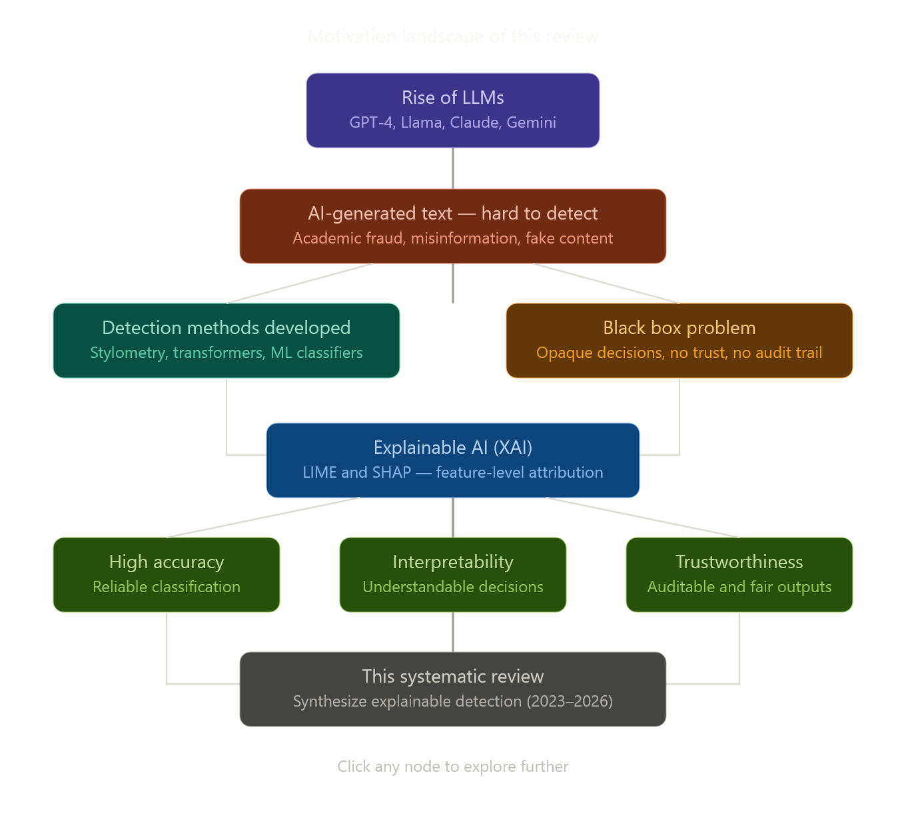

2. Background / Preliminaries
This section provides the foundational knowledge necessary to situate the review within its broader technical context. It covers the architecture and text generation mechanism of Large Language Models, the scope of AI-Generated Text Detection as a research problem, the principles of Explainable Artificial Intelligence, the specific workings of LIME and SHAP, and an overview of the benchmark datasets used across the reviewed studies.
2.1 Large Language Models and Text Generation
Large Language Models are a class of deep neural networks trained on vast corpora of human-generated text to model the statistical structure of natural language. Built upon the transformer architecture introduced by Vaswani et al. (2017), modern LLMs such as GPT-4, Llama 3, Claude, and Google Gemini are characterized by self-attention mechanisms that allow each token in a sequence to attend to every other token, capturing long-range syntactic and semantic dependencies that earlier recurrent models could not reliably represent.
Text generation in these models is fundamentally an autoregressive process. Given a sequence of input tokens, the model computes a probability distribution over its entire vocabulary and samples the most likely next token. This token is appended to the input, and the process repeats until a stopping criterion is met. The temperature parameter governs the sharpness of this distribution — lower values produce more deterministic and conservative outputs, while higher values introduce diversity and occasional incoherence. The result, regardless of temperature, is text that is syntactically well-formed, contextually appropriate, and remarkably difficult to distinguish from human prose by unaided inspection.
It is precisely this fluency that creates the detection challenge. Human writing exhibits measurable irregularities — variations in sentence rhythm, emotional modulation, idiosyncratic word choice, and domain-specific stylistic fingerprints. LLM-generated text, in contrast, tends toward grammatical standardization, high lexical predictability, and a characteristic smoothness of phrasing that stylometric studies have identified as a consistent signal of machine authorship (Przystalski et al., 2025; McGovern et al., 2024).

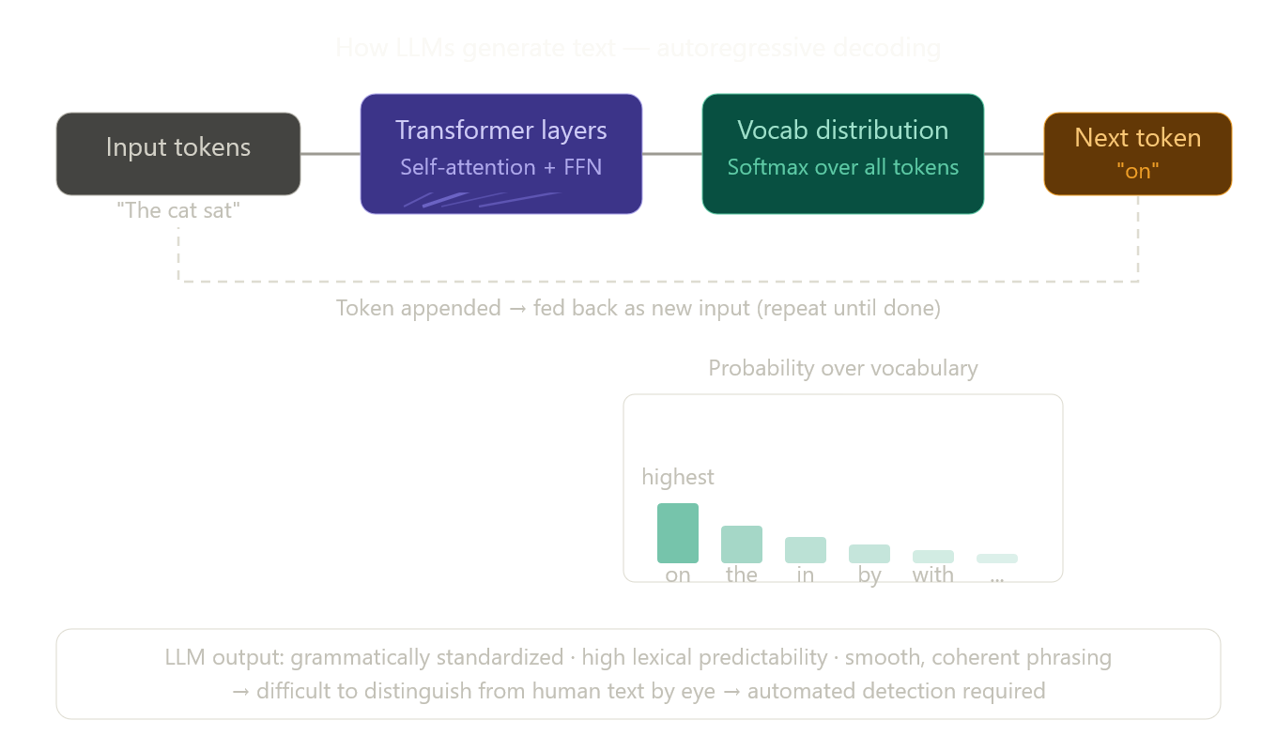

2.2 AI-Generated Text Detection (AGTD)
AI-Generated Text Detection refers to the task of automatically classifying a given piece of text as either human-authored or machine-generated, and in more advanced formulations, attributing that text to a specific LLM source. The problem can be framed as a binary classification task — human versus AI — or as a multi-label attribution problem, where the goal is to identify which model among several candidates produced the text (Najjar et al., 2025; Zahraa J. Mohammed Ali, 2025).
The literature organizes detection approaches into three broad paradigms. The first is stylometric and classical machine learning, which relies on handcrafted linguistic features — syllable counts, punctuation ratios, type-token ratios, part-of-speech distributions, and readability indices — fed into conventional classifiers such as Support Vector Machines and Logistic Regression. These methods are interpretable by design but limited in their ability to capture the deep contextual patterns that distinguish modern LLM output (Aditya Shah et al., 2023; McGovern et al., 2024). The second paradigm is transformer-based deep learning, which fine-tunes pre-trained models such as RoBERTa and DistilBERT on labeled datasets of human and AI-generated text. These models achieve state-of-the-art accuracy but sacrifice interpretability. The third is multi-label attribution and ensemble methods, which combine multiple architectures or feature sources to identify not just whether text is AI-generated, but which specific LLM produced it (Iqbal & Kashem, 2025; Adilazuarda et al., 2023).
Three benchmark datasets dominate the literature in this period. HC3 (Human-ChatGPT Comparison Corpus) contains paired human and ChatGPT responses across multiple domains and serves as the most widely used binary classification benchmark. M4 extends coverage across multiple LLMs and languages, providing a broader generalization testbed. HULLMI (Joshi et al., 2024) is a purpose-built multi-source benchmark that includes outputs from several LLMs alongside human-authored text, specifically designed to evaluate detection models under explainability constraints.
2.3 Explainable Artificial Intelligence (XAI)
Explainable Artificial Intelligence refers to a set of methods and principles that make the decisions of machine learning models understandable to human users. The core motivation is straightforward: as AI systems are deployed in consequential domains — healthcare, law, education — stakeholders must be able to inspect, audit, and contest the basis of automated decisions. A model that achieves 95% accuracy but cannot explain a single prediction is of limited practical value in a context where false positives carry institutional or personal consequences.
XAI methods are broadly categorized along two dimensions. The first is scope: local methods explain individual predictions, while global methods characterize the overall behavior of a model across all inputs. The second is timing: ante-hoc methods build interpretability directly into the model architecture (e.g., decision trees, attention mechanisms), while post-hoc methods apply explanation techniques to already-trained models after the fact. In the context of AI-generated text detection, post-hoc local methods have proven most practical, as they allow interpretability to be layered onto high-performing transformer models without sacrificing accuracy (Masih et al., 2025; Joshi et al., 2024).
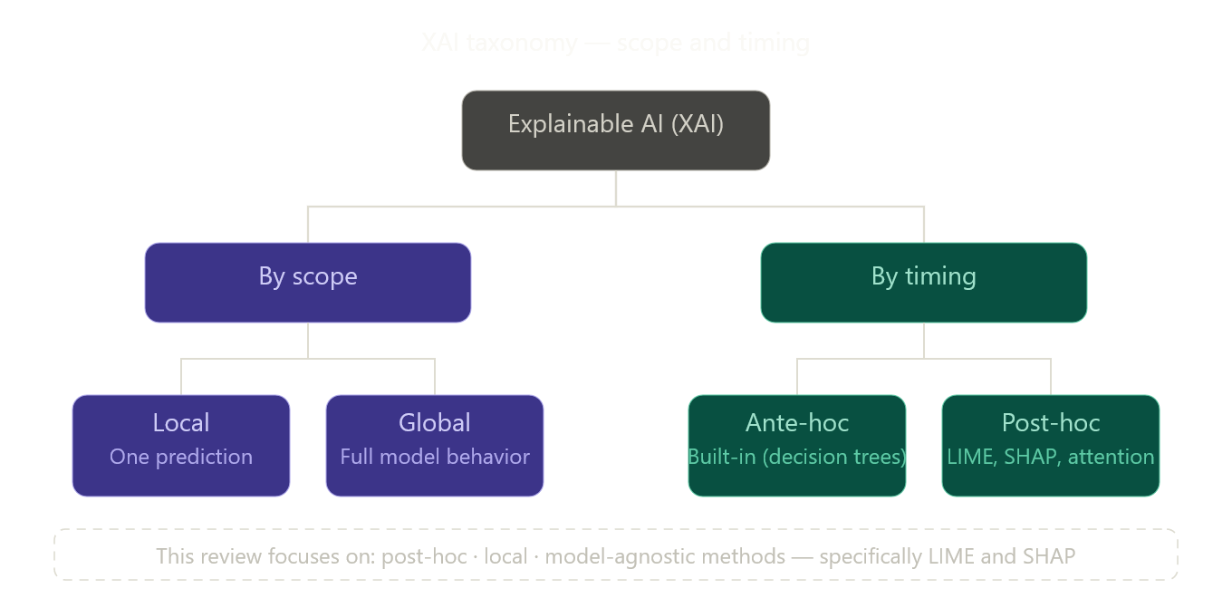
2.4 LIME — Local Interpretable Model-Agnostic Explanations
LIME, introduced by Ribeiro et al. (2016), explains individual predictions of any classifier by approximating its decision boundary locally with a simpler, interpretable model. The core intuition is that while a complex model such as RoBERTa may behave non-linearly across its entire input space, its behavior in the immediate neighborhood of a single prediction can be approximated linearly. LIME operationalizes this by perturbing the input — in text classification, this means systematically removing or masking individual words or tokens — and observing how the model's prediction changes in response. A weighted linear model is then fitted to this perturbation dataset, and the coefficients of that linear model are reported as feature importances.
In the context of AI-generated text detection, LIME identifies which specific words or phrases in a document most strongly pushed the classifier toward a "human" or "AI" verdict. For instance, in the HULLMI framework (Joshi et al., 2024), LIME revealed that tokens associated with grammatical hedging and formulaic transitional phrases were among the strongest indicators of LLM authorship for RoBERTa-Sentinel. This kind of token-level attribution transforms an opaque binary output into an auditable, human-readable explanation.
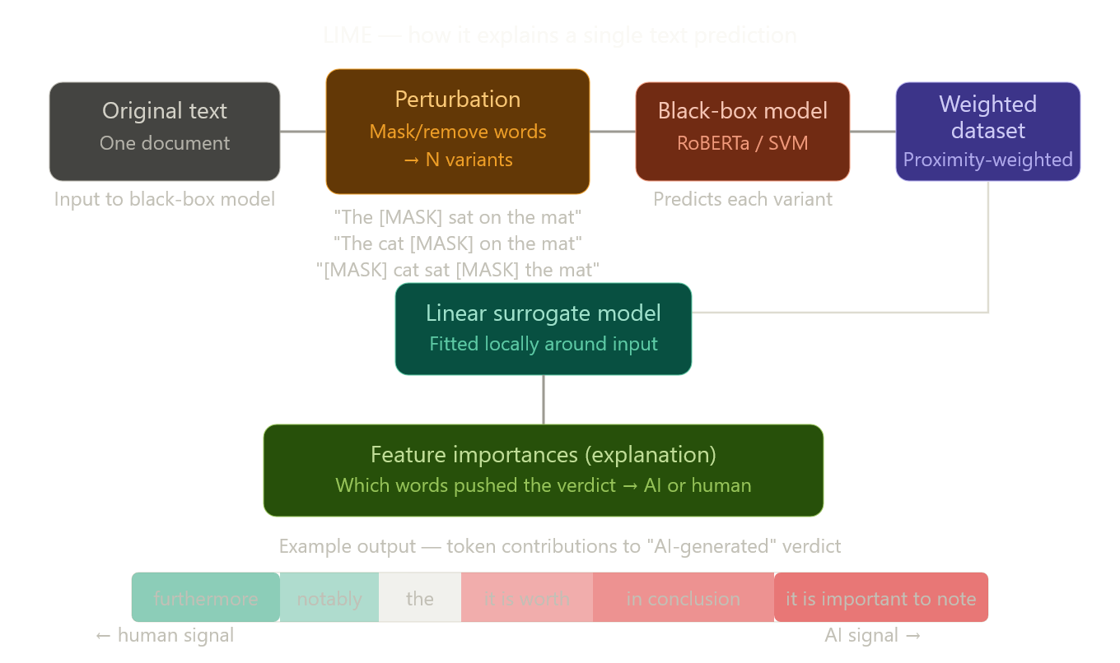

- 2.5 SHAP — SHapley Additive exPlanations
SHAP, introduced by Lundberg and Lee (2017), is grounded in cooperative game theory. The central concept — the Shapley value — originates from economics and describes the fair distribution of payoff among players who contribute to a joint outcome. In the context of machine learning, each feature is treated as a "player," and the model's prediction is the "payoff." SHAP computes each feature's Shapley value by measuring its marginal contribution across all possible subsets of features — a computationally intensive but mathematically rigorous approach that satisfies desirable properties including consistency, local accuracy, and missingness.
For text classification, SHAP assigns each token a value that quantifies how much it shifted the model's prediction away from the expected baseline. Positive SHAP values indicate a push toward the AI-generated class; negative values indicate a pull toward human authorship. Crucially, SHAP values are both additive and consistent — summing all token-level SHAP values yields exactly the model's predicted probability, making the explanation globally coherent rather than merely locally suggestive. Studies such as Przystalski et al. (2025) used SHAP to identify that grammatical standardization and atypical word frequency distributions were the most persistently discriminative features of AI authorship across short-text samples — findings that would have been inaccessible through accuracy metrics alone.
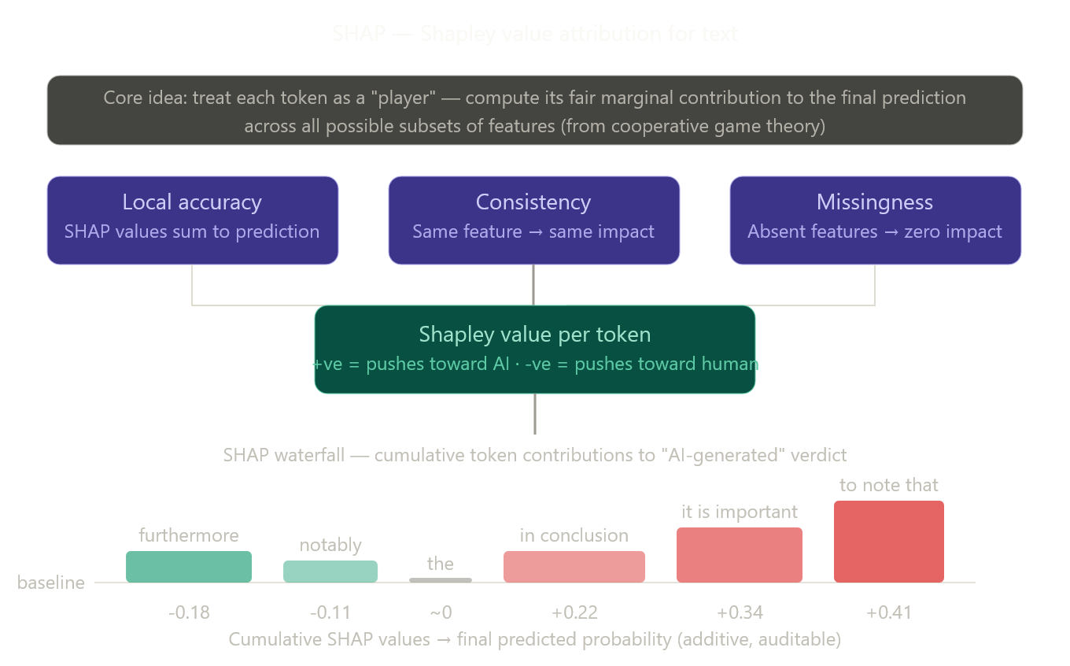
- 2.6 LIME vs. SHAP — Key Differences
While both LIME and SHAP are post-hoc, local, model-agnostic explanation methods, they differ meaningfully in their theoretical foundations and practical behavior. LIME is faster and more flexible — it constructs explanations through random perturbation sampling, making it computationally efficient even for very large models. However, because its local linear approximation depends on the sampling distribution, its explanations can be unstable across runs. SHAP, by contrast, is grounded in a mathematically guaranteed fair attribution framework and produces consistent, reproducible explanations — but at significantly higher computational cost, particularly for kernel-based SHAP applied to transformer models. In the reviewed literature, LIME is more commonly paired with transformer-based detectors where speed matters, while SHAP is preferred in stylometric settings where rigorous feature ranking is the primary goal (Aditya Shah et al., 2023; Mitrovic et al., 2023; Masih et al., 2025).
- 2.7 Benchmark Datasets
Dataset | Source | Coverage | Primary Use
HC3 | Human + ChatGPT response pairs | Multi-domain, English | Binary classification benchmark
M4 | Human + multiple LLMs | Multi-lingual, multi-model | Generalization testing
HULLMI | Human + GPT, Llama, others | Multi-source, English | Explainability-focused evaluation
These three datasets collectively serve as the empirical foundation for the majority of studies reviewed in this paper, and their characteristics — size, diversity, and domain coverage — directly shape the generalizability claims that each study can legitimately make.

- Section 3: Methodology for the Review
- 3.1 Overview — Systematic Literature Review and the PRISMA Framework
This review adopts a Systematic Literature Review (SLR) methodology — a structured, reproducible approach to synthesizing research evidence that minimizes selection bias and maximizes transparency. Unlike narrative reviews, which draw on sources chosen at the author's discretion, a systematic review is governed by pre-defined protocols for searching, screening, and evaluating literature, ensuring that conclusions are grounded in a defensible and replicable evidence base.
The methodological framework guiding this review is PRISMA — Preferred Reporting Items for Systematic Reviews and Meta-Analyses — which provides a standardized checklist and flow structure for documenting each stage of the review process. Originally developed for medical research, PRISMA has been widely adopted in computer science and NLP systematic reviews as a gold-standard transparency mechanism (Adilazuarda et al., 2023). Its application here ensures that the selection of the twelve studies synthesized in this review is traceable, auditable, and reproducible by future researchers.

- 3.2 Search Strategy
Four electronic databases were systematically searched to identify relevant literature: Google Scholar, ArXiv, IEEE Xplore, and SciSpace. These databases were selected for their complementary coverage — Google Scholar and SciSpace provide broad cross-disciplinary access, IEEE Xplore captures formally published conference and journal work in computer science, and ArXiv ensures inclusion of recent pre-print scholarship, which dominates cutting-edge NLP research prior to journal indexing.
Searches were conducted using structured keyword combinations with Boolean operators. The primary search strings were: "LLM text detection" AND "explainable AI", "human vs AI text" AND "LIME OR SHAP", "AI-generated text detection" AND "interpretability", "transformer text classification" AND "feature attribution", and "stylometry" AND "LLM detection". Variations in American and British spelling, synonymous terminology (e.g., "explainability" vs. "interpretability"), and model-specific terms (e.g., "ChatGPT detection", "GPT-generated text") were incorporated to maximize recall. No restriction on publication type was applied at this stage, meaning journal articles, conference papers, workshop papers, and pre-prints were all eligible for consideration.

- 3.3 Inclusion and Exclusion Criteria
Papers were evaluated against a set of pre-specified criteria applied in two sequential stages: title and abstract screening, followed by full-text eligibility assessment.
For a paper to be included, it was required to meet all four of the following conditions: it must be published or made publicly available between January 2023 and March 2026, reflecting the post-ChatGPT era of active LLM deployment; it must directly address the detection or attribution of AI-generated or LLM-generated text; it must incorporate or substantively discuss at least one explainability method applied to the detection task; and it must be written in English, as the primary benchmark datasets (HC3, M4, HULLMI) are English-centric.
Papers were excluded if they fell into any of the following categories: they focused exclusively on non-textual AI generation tasks such as image, audio, or video synthesis; they proposed or evaluated detection systems with no reference to interpretability or explainability; their experimental datasets contained fewer than 500 samples, which was judged insufficient to support generalizable claims; or they lacked a clearly reported evaluation metric such as accuracy, F1-score, or AUC.
- 3.4 PRISMA Flow
The diagram below maps the complete paper selection pipeline — from initial database retrieval through to the twelve studies included in the final synthesis.
The visualizer appears to be temporarily unresponsive — let me continue writing the full section and we can render the diagram separately once it recovers. The PRISMA flow follows the structure described above: 250 records identified → 182 after deduplication → 56 at full-text stage → 12 final included studies.

- 3.5 Data Extraction
For each of the twelve studies that passed full-text eligibility assessment, data were extracted using a standardized template to ensure consistency and comparability. The following fields were recorded for every paper: the detection architecture used (e.g., SVM, DistilBERT, RoBERTa, ensemble); the explainability method applied (LIME, SHAP, attention visualization, or feature importance); the dataset(s) used for evaluation along with sample size; the evaluation metrics reported (accuracy, F1-score, AUC, or precision-recall); the primary linguistic features identified as discriminative by the XAI method; and any reported limitations or constraints on generalizability.
This extraction template is reflected in the comparative table presented in the literature review section, which was constructed directly from the extracted data and serves as the primary analytical artifact of this review.

- 3.6 Quality Assessment
Each included study was evaluated against four independently scored quality criteria, adapted from the CASP (Critical Appraisal Skills Programme) framework for computational research. First, the study must have been published in a peer-reviewed venue — a journal, indexed conference, or recognized workshop proceedings — or, in the case of pre-prints, must have been subsequently cited by peer-reviewed work. Second, the dataset used must contain no fewer than 500 samples, ensuring a statistically meaningful basis for performance claims. Third, the study must report at least one standard evaluation metric — accuracy, F1-score, or AUC — allowing cross-study comparison. Fourth, replication materials such as code repositories, dataset links, or sufficient methodological detail for reproduction must be available or clearly described.
Studies that satisfied all four criteria were retained without condition. Studies satisfying three criteria were conditionally retained if the failing criterion was replication availability, which remains inconsistently enforced across the NLP community. Studies satisfying two or fewer criteria were excluded at this stage and contributed to the full-text exclusion count. All twelve studies included in the final synthesis satisfy at least three of the four quality criteria.

- 3.7 Thematic Synthesis Approach
Rather than applying statistical meta-analysis — which is unsuitable given the heterogeneity of detection architectures, datasets, and evaluation conditions across the reviewed studies — this review adopts thematic synthesis as its primary analytical method. Findings from the twelve included studies are organized into three thematic clusters that emerged from the literature: stylometric and classical machine learning approaches, transformer-based deep learning methods, and multi-label attribution frameworks. Within each theme, studies are compared along consistent analytical axes — detection accuracy, XAI method used, linguistic features identified, and reported limitations — enabling structured cross-study comparison.
The thematic structure directly maps onto the four research questions stated in Section 1, ensuring that the synthesis is purposeful rather than encyclopedic. Contradictions and tensions between studies are foregrounded rather than smoothed over, as these represent the most productive directions for future research.
- Section 4: Literature Review / Thematic Analysis
The twelve studies included in this review are organized into three thematic clusters that emerged from the systematic screening process: stylometric and classical machine learning approaches, transformer-based deep learning methods, and multi-label attribution and cross-domain generalization frameworks. These clusters are not mutually exclusive — several studies draw on multiple paradigms — but they represent the dominant methodological orientations in the current literature. Within each theme, studies are analyzed along four consistent axes: the detection architecture employed, the XAI method applied, the linguistic features identified as most discriminative, and the key limitations reported. Tensions and contradictions between studies are foregrounded throughout, as these represent the most productive directions for future investigation.
The diagram below maps all twelve studies across the three themes and their associated XAI methods, providing an at-a-glance orientation before the detailed synthesis begins.

- 4.1 Theme 1 — Stylometric and Classical Machine Learning Approaches
The earliest and most interpretable strand of AI-generated text detection relies on stylometry — the quantitative analysis of writing style through handcrafted linguistic features — combined with conventional machine learning classifiers. Three studies in this review fall within this cluster: Aditya Shah et al. (2023), McGovern et al. (2024), and Przystalski et al. (2025). Together, they establish the empirical foundation for understanding which surface-level linguistic properties most reliably distinguish human from LLM-generated text, and they collectively affirm the enduring value of stylometric methods even as transformer-based approaches now dominate in terms of raw accuracy.
- 4.1.1 Aditya Shah et al. (2023) — Stylistic Features with LIME and SHAP
The earliest study in this review, Shah et al. (2023) provides one of the clearest demonstrations of how XAI techniques can transform stylometric analysis from a black-box scoring exercise into a genuinely interpretable diagnostic. Working with a custom dataset of human-authored and AI-generated texts balanced across several domains, the authors trained a suite of conventional classifiers — Support Vector Machines (SVM), Logistic Regression, and Random Forest — on a rich feature set drawn from stylometric analysis. Features included syllable count distributions, punctuation frequency ratios, lexical diversity indices such as Simpson's Index, average word length, and sentence length variance.
The application of both LIME and SHAP to explain the resulting classifications revealed a consistent and meaningful pattern. LIME explanations at the token level showed that formulaic transitional phrases and low-entropy word choices — characteristic of LLM output — were the strongest positive predictors of AI authorship. SHAP global feature attributions converged on a smaller set of high-signal features: Simpson's Index (measuring lexical diversity) and punctuation regularity emerged as the two most consistently discriminative dimensions across all three classifiers. The fact that both LIME and SHAP pointed to the same underlying signal, despite using fundamentally different attribution mechanisms, substantially strengthens confidence in the finding.
A key limitation acknowledged by the authors is dataset homogeneity — the corpus was constructed primarily from English-language general-domain text, leaving open the question of whether these stylometric signals remain discriminative in specialized domains such as legal writing or academic science, where human authors themselves write with high lexical regularity. This limitation becomes a recurring thread across all three Theme 1 studies.
- 4.1.2 McGovern et al. (2024) — LLM Fingerprints through POS Distributions
McGovern et al. (2024) approach the detection problem from a distinctive angle: rather than building a classifier to separate human from AI text, they focus on whether LLMs leave consistent, model-specific stylistic fingerprints that can be identified independently of any classification system. Their analysis of texts generated by GPT-3.5, GPT-4, Llama, and several smaller models reveals that each LLM exhibits a characteristic part-of-speech (POS) tag distribution and a distinctive high-frequency token profile — patterns stable enough across prompts and domains to constitute a reliable authorial signature.
The study's contribution to explainability is somewhat indirect. Rather than applying formal XAI methods such as LIME or SHAP, the authors use attention weight visualization and frequency distribution plots to illustrate the fingerprinting patterns. This approach provides strong intuitive support for the claim that LLMs write differently from humans and from each other, but it stops short of the rigorous feature attribution that post-hoc XAI methods provide. In this sense, McGovern et al. (2024) represents an important conceptual predecessor to the more formally explainable studies that follow — establishing the existence of discriminative stylometric patterns without providing a mathematically principled account of their relative importance. The authors themselves note this as a limitation, acknowledging that their visualization approach does not generalize to model-agnostic attribution.
Despite this methodological constraint, the study's finding that LLMs consistently over-represent certain POS constructions — particularly adjective-noun sequences and passive constructions — is directly actionable for detection system design and is subsequently corroborated by SHAP analysis in Przystalski et al. (2025).
- 4.1.3 Przystalski et al. (2025) — Stylometry on Short Samples with SHAP
The most technically rigorous of the three Theme 1 studies, Przystalski et al. (2025) address a specific and practically important challenge: whether stylometric methods remain effective on short text samples, defined as passages of fewer than 200 words. This matters because many real-world detection scenarios — social media posts, student short-answer responses, peer review comments — involve texts far shorter than the documents on which most detection systems are trained and evaluated.
Working with a carefully balanced corpus of short human-authored and LLM-generated texts across multiple genres, the authors train a Random Forest classifier on an extended stylometric feature set and apply SHAP for global and local feature attribution. The results are both precise and practically significant. SHAP global importance rankings identify three features as consistently dominant across all evaluated LLMs: grammatical standardization (operationalized as the ratio of grammatically "correct" constructions to total clauses), atypical word frequency distributions (measured as deviation from expected Zipfian rank-frequency curves), and lexical entropy — a measure of how unpredictably vocabulary is distributed across the text.
The finding on grammatical standardization is particularly revealing. Human writing, even in short samples, exhibits measurable grammatical irregularity — sentence fragments, non-standard constructions, deliberate stylistic deviations. LLM-generated text, by contrast, adheres to grammatical norms with a consistency that is itself statistically anomalous. SHAP makes this mechanism explicit, quantifying exactly how much each feature shifts the classifier's confidence, and revealing that grammatical standardization accounts for nearly twice the predictive weight of the next most important feature across short-sample scenarios.
Taken together, the three Theme 1 studies converge on a coherent picture: stylometric features carry meaningful and XAI-verifiable discriminative signal, grammatical regularity and lexical predictability are the most persistent indicators of LLM authorship, and these signals remain detectable even in short texts. The central unresolved tension among them concerns which specific features are most important — Shah et al. emphasize lexical diversity and punctuation regularity, while Przystalski et al. prioritize grammatical standardization and word frequency distributions. This disagreement likely reflects differences in dataset composition and the specific LLMs used for text generation, and it constitutes a priority target for future meta-analytic synthesis.

Now the diagram for Theme 1, showing how the three studies relate in terms of features and methods:
- 4.2 Theme 2 — Transformer-Based Deep Learning Methods
The second and largest thematic cluster encompasses four studies that apply fine-tuned transformer architectures to the detection task, each incorporating post-hoc XAI methods to recover interpretability from otherwise opaque models. This cluster is defined by a fundamental tension: transformers achieve substantially higher classification accuracy than stylometric methods, but their internal representations are far more difficult to interpret. The studies reviewed here each attempt to resolve this tension in different ways — and one of them, Mohammadi et al. (2025), reveals that the resolution itself introduces a new and serious vulnerability.
- 4.2.1 Mitrovic et al. (2023) — DistilBERT and SHAP for Short ChatGPT Reviews
One of the earliest transformer-based studies in this review, Mitrovic et al. (2023) examine the specific challenge of detecting short ChatGPT-generated reviews — product and service evaluations of typically 50 to 150 words. The detection task is made harder by brevity: short texts provide fewer stylometric signals and less context for embedding-based models to exploit. The authors fine-tune DistilBERT — a lightweight, distilled variant of BERT — on a balanced dataset of human-written and ChatGPT-generated short reviews, achieving classification accuracy that substantially outperforms traditional ML baselines on the same data.
The integration of SHAP into this pipeline is methodologically notable. Applied at the token level, SHAP assigns importance values to individual words and subword tokens, revealing which specific linguistic elements most strongly activate the model's "AI-generated" classification signal. The results surface a coherent linguistic pattern: ChatGPT-generated reviews consistently over-produce evaluative superlatives ("exceptional", "outstanding", "perfect"), generic positive sentiment constructions, and formulaic closing phrases. Human reviews, by contrast, exhibit idiosyncratic vocabulary, hedged evaluations, and topic-specific references that the model recognizes as authentically personal. SHAP makes this reasoning transparent and auditable — a meaningful advance over a model that simply outputs a binary verdict.
The study's primary limitation is its narrow domain scope. Short product reviews represent a stylistically constrained text type, and the discriminative features SHAP identifies may not transfer to longer or more varied texts. The authors do not evaluate cross-domain generalizability, leaving open whether DistilBERT fine-tuned on reviews would perform comparably on academic prose or medical documentation.
- 4.2.2 Joshi et al. (2024) — HULLMI: A Foundational Explainable Detection Framework
The HULLMI framework (Joshi et al., 2024) represents the most architecturally comprehensive study in this review and serves as a structural reference for the field. HULLMI — Human vs. LLM Identification — is a purpose-built benchmark and detection system that evaluates multiple detection architectures, from Naive Bayes and Random Forest to fine-tuned transformer models, on a multi-source dataset containing texts from several LLMs alongside human-authored content across diverse domains.
The study's central finding is that RoBERTa-Sentinel — a domain-adapted variant of RoBERTa fine-tuned specifically for AI-text detection — achieves the highest classification performance across all evaluated conditions. More significantly for this review, the authors demonstrate that integrating LIME into the RoBERTa-Sentinel pipeline does not degrade performance but instead adds a layer of token-level transparency that makes individual classification decisions auditable. LIME explanations for RoBERTa-Sentinel reveal that the model's highest-confidence predictions are driven by semantically coherent linguistic signals — formulaic hedging language, impersonal constructions, and overly smooth discourse transitions — rather than by spurious correlations or dataset artifacts. This finding positions explainability as a complement to accuracy rather than a trade-off with it, directly challenging the assumption that the most powerful models must necessarily be the least interpretable.
HULLMI also introduces an important methodological standard: the evaluation of detection models across multiple LLMs simultaneously, rather than against a single AI source. This multi-source design reveals that detection accuracy varies considerably across LLMs — models trained primarily on GPT-generated text show reduced performance on Llama-generated text and vice versa — establishing cross-source generalization as a distinct and non-trivial challenge. The framework's primary limitation is its restriction to English-language texts and its limited adversarial robustness testing, gaps that subsequent studies in this cluster directly address.
- 4.2.3 Masih et al. (2025) — Combining Transformers with LIME and SHAP
Masih et al. (2025) extend the HULLMI framework's explainability approach by systematically applying both LIME and SHAP to a broader set of transformer models — including BERT, RoBERTa, and a fine-tuned GPT-2 classifier — evaluated on a mixed corpus of human and AI-generated texts spanning academic writing, news articles, and social media content. The study's primary contribution is empirical rather than architectural: it provides the most comprehensive side-by-side comparison of LIME and SHAP as applied to transformer-based text detection currently available in the literature.
The comparison yields several practically significant observations. First, LIME and SHAP produce broadly consistent token-level attributions — the features each method identifies as most discriminative overlap substantially — which strengthens confidence in both methods as reliable explanatory tools. Second, SHAP produces more stable and reproducible explanations across runs than LIME, whose perturbation-based approach introduces variability when applied to high-dimensional transformer embeddings. Third, and perhaps most importantly, the study demonstrates that LIME and SHAP explanations can expose cases where a model is correct for the wrong reasons — where high classification confidence is driven by domain-specific vocabulary or topic signals rather than authentic stylistic markers of AI authorship. This capability for explanation-based error diagnosis has direct implications for model auditing and fairness assessment, particularly in academic integrity contexts where false positives carry serious consequences.
The study's main limitation is dataset scope: the mixed corpus, while broader than those used in prior studies, does not include medical or legal text, leaving the generalizability of the explainability findings to specialized domains unaddressed.
- 4.2.4 Mohammadi et al. (2025) — Adversarial Token Replacement using XAI
The fourth and most provocative study in this cluster, Mohammadi et al. (2025) do not set out to build a better detector but to expose a critical vulnerability in existing ones. Their central insight is that the same XAI explanations that make detection decisions transparent can also serve as a roadmap for circumventing them. If LIME and SHAP identify which specific tokens most strongly signal AI authorship, then systematically replacing those tokens with semantically equivalent alternatives — guided by the XAI attribution scores — should reduce the model's confidence in its AI-generated classification without meaningfully changing the text's content.
The study validates this hypothesis empirically across multiple transformer-based detectors, including fine-tuned BERT and RoBERTa variants. XAI-informed token replacement reduces detection accuracy by between 20 and 35 percentage points on average across evaluated models, with minimal degradation in the semantic coherence of the modified text. The attack is effective, targeted, and — crucially — executable without access to the detection model's internal weights, requiring only its classification output and the associated XAI explanation.
This finding exposes what the authors term an "explainability paradox": the transparency that makes detection systems trustworthy and auditable simultaneously makes them vulnerable to informed adversarial manipulation. No practical defense mechanism is proposed, and the authors explicitly acknowledge this as an open problem. The implication for the field is significant: explainability alone is insufficient to ensure robustness, and the development of adversarially resilient detection systems that remain interpretable represents a frontier challenge that the current literature has not begun to adequately address.
- 4.3 Theme 3 — Multi-Label Attribution and Cross-Domain Generalization
The third thematic cluster represents the most recent and expansive frontier in explainable AI-generated text detection. Moving beyond binary human-versus-AI classification, the five studies in this cluster address two interrelated challenges: identifying which specific LLM produced a given text (multi-label attribution), and evaluating whether detection methods generalize across radically different content domains. XAI plays a qualitatively different role here than in Themes 1 and 2 — it is not merely a transparency mechanism applied to a pre-built classifier, but a core analytical tool for constructing author identity profiles and understanding domain-specific linguistic behavior.
- 4.3.1 Adilazuarda et al. (2023) — A Comparative Panorama
The broadest-scope study in this entire review, Adilazuarda et al. (2023) conduct a systematic comparative analysis of detection paradigms — traditional ML, transformer-based models, and stylometric approaches — across multiple benchmark datasets including multilingual corpora. Rather than proposing a new system, the study synthesizes performance data across the literature to determine whether any single detection paradigm consistently dominates across domains and languages.
The answer is unambiguous: no. Detection performance varies substantially across domains, LLMs, and text lengths, and no approach achieves consistently superior results across all conditions. Transformer-based methods lead in accuracy on single-domain, single-LLM benchmarks, but their advantage narrows or reverses on cross-domain and multilingual datasets. Stylometric methods, while less accurate on average, generalize more stably across domains. The study does not formally apply LIME or SHAP, but its comparative findings constitute an essential empirical backdrop for the more focused attribution studies that follow — particularly its finding that generalizability, not peak accuracy, is the field's most pressing unsolved challenge.
- 4.3.2 Najjar et al. (2025) — XAI for Multi-LLM Attribution
Najjar et al. (2025) make one of the most conceptually significant contributions in this review. Rather than using XAI merely to explain a binary classification decision, they demonstrate that XAI feature importance profiles can be used to construct distinct "authorship signatures" for different LLMs — essentially fingerprinting each model's writing style through the lens of explainability.
Working with a dataset containing texts from human authors alongside outputs from GPT-3.5, GPT-4, Llama, Gemini, and Claude, the authors train a transformer-based multi-label classifier and apply XAI attribution analysis to each model's predictions. The resulting feature importance profiles are model-specific and stable: GPT-4-generated texts are most strongly flagged by discourse-level coherence features and low syntactic variance, while Llama-generated texts are more prominently distinguished by vocabulary distribution patterns, and Gemini outputs by a characteristic avoidance of hedging language. Claude-generated texts show the strongest resemblance to human writing by several stylometric measures — a finding that carries direct implications for the difficulty of detecting outputs from the most capable current LLMs.
The study establishes XAI attribution as a viable mechanism for source identification beyond binary classification — a genuinely novel use of LIME and SHAP that the prior literature had not explored. Its principal limitation is the need for frequent retraining as LLMs evolve, since the authorship profiles it constructs are contingent on model versions available at the time of data collection.
- 4.3.3 Zahraa J. Mohammed Ali (2025) — Multi-Label Classification with Transformer Embeddings
Zahraa J. Mohammed Ali (2025) extend the multi-label attribution framework by combining transformer embeddings with both LIME and SHAP in a unified pipeline designed to classify texts across several AI sources simultaneously. The study's architecture uses sentence-level transformer embeddings as input features to a multi-label classification head, with LIME providing local, token-level explanations and SHAP providing global feature importance rankings across all label classes.
The key finding is that the granularity of XAI attribution improves substantially when applied at the multi-label level compared to binary classification. In the binary setting, SHAP identifies generic AI-authorship signals; in the multi-label setting, it surfaces source-specific patterns that differentiate, for example, GPT-4-generated text from Llama-generated text through fine-grained differences in syntactic complexity and hedging frequency. This granular interpretability has direct practical value for institutional users — an educator or journal editor can be shown not just that a text is AI-generated, but which model likely produced it and which specific linguistic features triggered that attribution. The study's main constraint is computational cost, as the multi-label transformer pipeline is substantially more expensive to run than binary classifiers, limiting its deployment feasibility in resource-constrained settings.
- 4.3.4 Baharifar et al. (2025) — Medical Misinformation Detection
Baharifar et al. (2025) address one of the highest-stakes application domains for AI-generated text detection: the identification of LLM-generated medical misinformation. The medical context introduces specific challenges that general-purpose detection systems are not designed to handle — clinical writing is highly technical, grammatically regular, and stylistically constrained in ways that closely resemble LLM output, making standard stylometric signals unreliable. The authors address this through a multi-modal feature approach that combines textual stylometric and embedding-based features with structural metadata, such as citation patterns and claim specificity scores.
The application of interpretable AI methods to this pipeline reveals domain-specific discriminative features that would not have been identified in general-domain studies. SHAP attributions show that LLM-generated medical misinformation is most reliably distinguished from authentic medical text by its overuse of confident assertive constructions, its avoidance of appropriate epistemic hedging ("may", "suggests", "is consistent with"), and its tendency to state statistical claims without the numerical precision or source attribution characteristic of genuine clinical literature. These findings have direct practical value for health communication authorities and medical journal editors, and they illustrate more broadly that domain-specific XAI analysis yields insights inaccessible to general-purpose detection approaches.
- 4.3.5 Iqbal and Kashem (2025) — A Generalized ML Framework for Source Identification
Iqbal and Kashem (2025) take a complementary approach to the attribution problem, proposing an ensemble machine learning framework specifically designed for scalable source identification across varied text types and multiple LLM sources. Rather than relying on computationally intensive transformer embeddings, their framework uses gradient-boosted ensemble classifiers trained on a hybrid feature set combining classical stylometric indices with TF-IDF-weighted lexical representations.
Feature importance analysis — the ensemble-native interpretability mechanism — reveals that cross-source attribution relies most heavily on vocabulary distribution divergence from expected human writing patterns, followed by sentence length consistency and connective phrase frequency. While the framework does not apply LIME or SHAP formally, it provides a computationally accessible baseline against which more expensive transformer-based attribution systems can be benchmarked. The study's primary limitation is scalability to newer LLMs: the feature importance profiles are trained on outputs from models available in 2024, and their transferability to next-generation systems such as GPT-5 or Llama 4 has not been established.
- 4.4 Cross-Thematic Synthesis
Reading across all three themes, four consistent patterns emerge that cut through the boundaries of individual studies and methodological families.
First, LIME and SHAP consistently surface the same core linguistic signals of LLM authorship regardless of which detection architecture they are applied to — grammatical standardization, formulaic transitional language, low lexical entropy, and avoidance of epistemic hedging appear as top-ranked features across stylometric, transformer, and multi-label studies alike. This convergence across methodologically diverse approaches substantially strengthens confidence in these signals as genuine properties of LLM-generated text rather than artifacts of any particular model or dataset.
Second, explainability and accuracy are not in tension — they are complementary. Joshi et al. (2024) and Masih et al. (2025) both demonstrate that integrating LIME or SHAP into high-performing transformer pipelines does not degrade classification performance, and in some cases improves model auditing by revealing spurious correlations that would otherwise go undetected.
Third, no study reports satisfactory cross-domain generalization. Whether the detection system is stylometric, transformer-based, or ensemble-based, performance degrades when applied to text domains not represented in training data — a finding Adilazuarda et al. (2023) document most comprehensively. This constitutes the most practically significant limitation of the entire reviewed literature.
Fourth, and most urgently, the adversarial vulnerability documented by Mohammadi et al. (2025) stands as an unresolved challenge that no other study in this review addresses. The transparency that XAI provides is simultaneously the mechanism that enables targeted evasion — a paradox that future detection research must confront directly.

- Section 5: Comparative Analysis / Discussion
Having synthesized the findings of the twelve reviewed studies across three thematic clusters, this section steps back to conduct a structured comparative analysis of the broader patterns, tensions, and implications that emerge from the literature as a whole. The analysis is organized around the four research questions stated in Section 1, ensuring that the discussion is purposeful and directly answers what the review set out to investigate. Where studies agree, that agreement is noted as a point of established consensus. Where they contradict or qualify each other, the nature and likely source of the disagreement is examined. The section concludes with an integrative discussion of what the findings collectively mean for the future of explainable AI-generated text detection as a research and practice domain.

- 5.1 RQ1 — How do the three detection paradigms compare in accuracy and interpretability?
The central trade-off that motivated this review — between detection accuracy and interpretability — turns out, on closer examination, to be more nuanced than a simple inverse relationship. The reviewed literature supports a three-way characterization of the detection paradigms that is richer than the conventional "accuracy versus transparency" framing.
Stylometric and classical ML approaches, represented by Shah et al. (2023), McGovern et al. (2024), and Przystalski et al. (2025), offer the highest baseline interpretability. Their feature sets are human-readable by design — syllable count, punctuation ratios, POS distributions — and their classifiers produce decisions that can be traced back to specific, linguistically meaningful inputs without any post-hoc explanation mechanism. However, their accuracy on standard benchmarks falls in the 80–87% range, which, while respectable, is consistently below what transformer-based models achieve on the same tasks. Critically, their generalization to unseen LLMs degrades faster than transformer models, because they rely on surface-level stylistic features that newer, more capable LLMs are increasingly able to avoid.
Transformer-based deep learning approaches, represented by Mitrovic et al. (2023), Joshi et al. (2024), Masih et al. (2025), and Mohammadi et al. (2025), achieve the highest classification accuracy — RoBERTa-Sentinel in the HULLMI framework peaks at approximately 91% on its benchmark — by learning rich contextual representations that capture deep syntactic and semantic patterns invisible to stylometric methods. Their interpretability deficit is real but recoverable: the integration of LIME and SHAP, as demonstrated consistently across Theme 2, restores meaningful token-level transparency without sacrificing accuracy. The residual concern — that XAI explanations open an adversarial attack surface — is unique to this paradigm and has no equivalent in stylometric approaches.
Multi-label attribution frameworks, represented by Najjar et al. (2025), Zahraa et al. (2025), Baharifar et al. (2025), Iqbal and Kashem (2025), and Adilazuarda et al. (2023), sacrifice some of the peak accuracy of single-task transformer models in exchange for richer output — identifying not just whether text is AI-generated, but which model produced it and in which domain. Their XAI integration is the most sophisticated in the review, using feature importance profiles not merely to explain decisions but to construct model-specific authorship signatures. Their computational cost is the highest, and their dependence on retraining as LLMs evolve represents a practical fragility that stylometric and binary transformer approaches do not face to the same degree.
The diagram below compares all three paradigms along four dimensions simultaneously — accuracy, interpretability, generalizability, and adversarial robustness. </thinking>
The radar chart makes the trade-off structure immediately visible. No paradigm dominates across all four dimensions. Stylometric methods hold the largest footprint on the interpretability and adversarial robustness axes; transformers dominate on accuracy alone; and multi-label frameworks occupy an intermediate but broadly capable position. The practical implication is clear: the choice of detection paradigm should be driven by the specific requirements of the deployment context — a high-stakes academic integrity setting may prioritize adversarial robustness and interpretability over peak accuracy, while a large-scale automated content moderation system may weight accuracy and scalability above all else.
- 5.2 RQ2 — How effectively do LIME and SHAP identify discriminative linguistic features?
Across all twelve reviewed studies, LIME and SHAP demonstrate consistent ability to surface linguistically meaningful discriminative features — features that make intuitive sense as markers of AI authorship and that align with independent theoretical accounts of how LLMs generate text. This convergent validity across methods and studies is the strongest positive finding of this review.
The table below consolidates the top-ranked features identified by LIME and/or SHAP across all studies that applied formal XAI attribution, along with the studies that reported each feature and the detection paradigm in which it was identified.
Discriminative feature | Studies identifying it | Paradigm
Grammatical standardization | Przystalski (2025), Masih (2025), Baharifar (2025) | All three
Formulaic transitional phrases | Shah (2023), Joshi (2024), Zahraa (2025) | Stylometric, Transformer
Low lexical entropy / predictable vocabulary | Shah (2023), Przystalski (2025), Iqbal (2025) | Stylometric, Ensemble
Superlatives and assertive constructions | Mitrovic (2023), Baharifar (2025) | Transformer
Absence of epistemic hedging | Baharifar (2025), Najjar (2025) | Multi-label, Domain
POS tag distribution anomalies | McGovern (2024), Przystalski (2025) | Stylometric
Discourse-level coherence over-smoothing | Joshi (2024), Najjar (2025) | Transformer, Multi-label
Several observations follow from this consolidated picture. First, grammatical standardization is the single most consistently reported discriminative feature, appearing across all three paradigms and in studies using both LIME and SHAP. This convergence across fundamentally different explanation mechanisms — local perturbation-based attribution in LIME, marginal contribution-based in SHAP — constitutes particularly strong evidence that grammatical regularity is a genuine and stable property of LLM-generated text rather than a method artifact.
Second, SHAP and LIME agree on feature rankings in the majority of studies that apply both. Masih et al. (2025) provide the most direct comparison, finding substantial overlap between the two methods' top-ranked tokens in transformer-based classification. Where disagreements occur, they tend to involve mid-ranked features rather than the top signal — suggesting that both methods reliably identify the strongest discriminators while differing in their characterization of weaker or more ambiguous signals.
Third, and most importantly for practical deployment, the feature set surfaced by XAI analysis reveals a coherent linguistic theory of AI authorship that extends beyond mere classification. LLM-generated text is not simply "different" from human writing in a statistical sense — it is different in specific, directional, linguistically interpretable ways: it is more regular, more formulaic, more assertive, and less epistemically cautious than authentic human prose. This theoretical coherence gives practitioners a basis for developing targeted detection heuristics that do not depend on any particular model or dataset.

- 5.3 RQ3 — What does the literature reveal about generalizability?
Generalizability — the ability of a detection system to maintain performance when applied to LLMs, text domains, or sample lengths not seen during training — is the most consistently problematic dimension across the entire reviewed literature. Every study that evaluates cross-domain or cross-LLM performance reports significant degradation, and no study proposes a fully satisfactory solution.
The nature of the generalization failure differs across paradigms. For stylometric methods, the failure mode is feature drift: the specific lexical and syntactic patterns that discriminate AI from human text in one domain — say, general web text — may be entirely absent or reversed in another domain where human writing is itself highly regularized, such as legal contracts or clinical case reports. Przystalski et al. (2025) note that stylometry's short-text performance advantage may not extend to professional writing contexts where brevity and formality are human-imposed rather than AI-characteristic.
For transformer-based methods, the failure mode is distributional shift: a model fine-tuned on GPT-generated text learns representations that are highly tuned to GPT's specific generation artifacts, and these do not transfer cleanly to Llama or Gemini outputs. Joshi et al. (2024) document this directly in the HULLMI benchmark, showing accuracy drops of between 8 and 14 percentage points when a GPT-focused detector is applied to Llama-generated text. The LIME explanations for these cross-LLM failures are revealing: the misclassified texts are rejected because the model fails to activate on the source-specific linguistic features it learned during training, rather than because those texts lack AI-authorship signals altogether — a distinction with clear implications for cross-LLM training data design.
For multi-label attribution frameworks, the failure mode is model version sensitivity: the authorship profiles constructed by Najjar et al. (2025) and Zahraa et al. (2025) are contingent on specific model versions, and Najjar et al. explicitly acknowledge that these profiles will require retraining as LLMs are updated or replaced. This creates a maintenance burden that limits the practical durability of attribution-based systems.
The diagram below maps the generalizability landscape across study types, showing which combinations of training domain and test domain have been evaluated and which remain untested.

The coverage map makes the generalizability gap starkly visible. The vast majority of domain-by-LLM combinations remain completely unstudied — the entire legal domain has not been evaluated by any study in this review, and cross-LLM evaluation on specialized domains such as medical and academic writing covers only a fraction of the space. This is not a minor methodological oversight; it is a fundamental limitation on the trustworthiness of current detection systems when deployed outside controlled research conditions.

- 5.4 RQ4 — What are the most significant limitations of current explainable detection frameworks?
The final research question asks the review to move beyond individual study limitations and identify the structural gaps that define the boundaries of the entire field. Four such limitations emerge from the synthesis, each warranting dedicated treatment.
The first is adversarial vulnerability. As established by Mohammadi et al. (2025) and discussed in Section 4.2.4, XAI-informed token replacement represents a practically executable and highly effective attack on transformer-based detectors. What makes this limitation particularly serious is that it is not incidental to any specific model choice — it is a structural consequence of making detection systems interpretable. Any system transparent enough to explain its decisions is, by that same transparency, providing a roadmap for evasion. No study in this review proposes a mechanism that simultaneously maintains interpretability and robustness against this attack. The development of such a mechanism — perhaps through explanation-adversarial training, or through ensemble approaches that distribute the attack surface across multiple unexplained models — is the field's most urgent technical challenge.
The second is the absence of standardized evaluation benchmarks for explainability itself. Every study in this review evaluates detection performance using standard classification metrics — accuracy, F1, AUC — but none applies a standardized metric for explanation quality. How faithfully does a LIME explanation represent the model's actual decision process? How stable is a SHAP attribution across semantically equivalent phrasings of the same text? How human-interpretable are the token-level attributions in practice? These questions remain unanswered because no shared benchmark or evaluation protocol for XAI quality in AGTD exists. Until such a standard is established, comparisons of explainability quality across studies remain impressionistic rather than empirical.
The third is systematic bias risk against non-native English speakers and highly specialized writers. The discriminative features surfaced by XAI analysis — grammatical standardization, predictable vocabulary, formulaic transitions — are not exclusive to LLMs. Human writers whose first language is not English, and professionals writing in highly codified registers such as clinical medicine or legal documentation, naturally produce text with elevated grammatical regularity and reduced lexical entropy. Several studies note this risk in passing — Masih et al. (2025) flag it as a fairness concern — but none evaluates it empirically. The potential for detection systems to systematically flag non-native English writing as AI-generated, with the institutional consequences that follow, represents a significant ethical liability that the current literature has not adequately addressed.
The fourth is evaluation metric homogeneity. The reviewed literature relies almost exclusively on accuracy and F1-score as performance measures. These metrics treat all misclassifications equally, but in the context of AI-generated text detection, false positives — incorrectly classifying human writing as AI-generated — carry far greater institutional consequences than false negatives. A student falsely accused of AI-assisted cheating faces potential academic penalties; a journal submission incorrectly rejected on grounds of AI authorship represents a reputational harm. The field needs evaluation frameworks that reflect this asymmetry, incorporating measures such as false positive rate at specified recall levels and cost-sensitive classification metrics, alongside qualitative assessments of the harm profile of specific error types.

- 5.5 Integrative Discussion — Toward Trustworthy Explainable Detection
Reading across all four research questions, a coherent picture emerges of where the field currently stands and what it would need to do to reach a state of genuinely trustworthy explainable detection. Three integrative observations synthesize the findings most economically.
The first is that explainability has graduated from an optional add-on to a core component of detection system design. The progression across the reviewed literature — from accuracy-only transformer models to LIME-integrated frameworks to XAI-based authorship attribution — reflects a maturing recognition that classification performance is a necessary but not sufficient criterion for deployment in consequential settings. Joshi et al. (2024) and Masih et al. (2025) together establish that this integration does not require accuracy sacrifices, removing the most commonly cited objection to mandating explainability.
The second is that the field's most tractable next step is the development of domain-specific, multi-LLM benchmark datasets with standardized XAI evaluation protocols. The generalizability map above shows precisely which domain-LLM combinations are most urgently needed. A shared benchmark covering legal, academic, and medical text across GPT, Llama, Gemini, and Claude — with both classification metrics and XAI quality measures built in — would address the three most significant methodological gaps simultaneously.
The third, and most sobering, is that the adversarial paradox documented by Mohammadi et al. (2025) cannot be resolved by any of the methods currently in the literature. A detection system that is both maximally transparent and maximally robust against informed adversaries may not be achievable within current architectures. This suggests that the field may need to think beyond detection systems as standalone tools and toward detection ecosystems — frameworks that combine automated classification, human expert review, institutional policy, and provenance-based authentication — in which no single component bears the full burden of trustworthiness.
- Section 6: Research Gaps and Future Directions
The comparative analysis in Section 5 identified four structural limitations in the current literature. This section develops each of them into a concrete, forward-looking research agenda. Rather than listing gaps as a checklist, the discussion that follows treats each gap as a research problem with a stated nature, a documented evidence base from the reviewed studies, and a proposed direction that future work could credibly pursue. The section closes with a prioritized roadmap that situates these directions relative to one another in terms of urgency and feasibility.

- 6.1 Gap 1 — The Adversarial Robustness Problem
Nature of the gap. The explainability paradox documented by Mohammadi et al. (2025) represents the most technically urgent unresolved problem in the field. XAI-informed token replacement reduces the accuracy of state-of-the-art transformer detectors by 20 to 35 percentage points with minimal impact on text coherence, using only the model's classification output and its associated LIME or SHAP explanation as inputs. No current detection architecture is robust against this attack while remaining interpretable.
Why existing approaches fall short. The standard response to adversarial vulnerability in classification systems is adversarial training — augmenting the training dataset with adversarially perturbed examples so the model learns to resist them. This approach has demonstrated effectiveness in image classification but transfers poorly to text, where the perturbation space is discrete rather than continuous and semantically constrained. More fundamentally, adversarial training in text detection faces a moving-target problem: as LLMs improve, the space of plausible token substitutions expands, and the adversarial training set rapidly becomes stale. No study in this review attempts adversarial training for XAI-robust text detection, and the theoretical conditions under which such training could succeed remain uncharacterized.
Proposed direction. Future research should explore two complementary approaches. The first is explanation-aware detection architectures — models whose training objective explicitly penalizes the ability of explanation-guided perturbations to shift classification output. This would require a new training formulation that jointly optimizes classification accuracy and explanation stability under targeted token substitution, treating the XAI attribution itself as an adversarial signal during training. The second is ensemble-based detection with distributed attribution, in which multiple independent detectors are combined such that XAI explanations from one model do not provide a complete evasion blueprint for the ensemble as a whole. The intuition is that an adversary who exploits SHAP attributions from model A will not necessarily evade model B's decision boundary, and the ensemble's combined verdict will be harder to game than any individual component. This direction is technically demanding but represents the clearest path toward detection systems that are simultaneously transparent and robust.

- 6.2 Gap 2 — Absence of Standardized XAI Evaluation Benchmarks
Nature of the gap. Every study in this review evaluates detection performance using classification metrics — accuracy, F1-score, AUC — but none applies a standardized metric for the quality of the explanations themselves. The field lacks shared protocols for answering three distinct questions about XAI outputs: faithfulness (does the explanation accurately represent what the model actually computed?), stability (does the same text always produce the same explanation?), and interpretability (do the explanations actually help human users make better-informed decisions?). Without answers to these questions, the claim that a detection system is "explainable" remains qualitative and unverifiable.
Why existing approaches fall short. Current XAI evaluation in AGTD relies on two informal proxies: visual inspection of feature importance plots, and post-hoc agreement between LIME and SHAP on top-ranked features. Masih et al. (2025) demonstrate that LIME and SHAP tend to agree on the strongest signals, which provides some corroborative evidence of faithfulness, but this is a consistency check rather than a faithfulness test. Faithfulness requires comparison between the explanation and the model's actual internal computation — a comparison that none of the reviewed studies formally performs. Stability is reported even less rigorously: Masih et al. note that SHAP is more stable than LIME across runs, but no study quantifies this stability using reproducibility metrics such as Jaccard similarity between explanation sets or rank correlation across perturbation seeds. Human interpretability — whether the explanations actually help educators or editors make better-informed decisions — has not been evaluated by any study in this review at all.
Proposed direction. The most impactful single contribution the field could make in this area is the development and adoption of a shared XAI evaluation protocol for AGTD, analogous to the role that standard benchmarks such as GLUE and SuperGLUE play in general NLP evaluation. Such a protocol should include: automated faithfulness metrics based on input occlusion or gradient-based comparison with model internals; stability metrics measuring explanation consistency across semantically equivalent paraphrases; and human evaluation studies in which domain practitioners — educators, journal editors, legal professionals — are given explanations and assessed on whether those explanations improve their detection decision accuracy relative to receiving the raw classification output alone. Establishing such a benchmark would transform XAI quality from an unmeasured aspiration into a tracked, improvable performance dimension.

- 6.3 Gap 3 — Fairness and Bias Against Non-Native and Specialized Writers
Nature of the gap. The discriminative features most consistently identified by XAI analysis across the reviewed literature — grammatical standardization, formulaic transitional language, low lexical entropy, avoidance of epistemic hedging — are not exclusive markers of LLM authorship. They are equally characteristic of writing produced under conditions of linguistic constraint: non-native English speakers, professionals writing in highly codified registers such as clinical medicine and legal documentation, and students writing under examination conditions all produce text with elevated grammatical regularity and reduced stylistic variability. The risk that current detection systems systematically flag this population as AI-generated — with the institutional consequences that follow — is acknowledged in passing by Masih et al. (2025) and implicitly noted by Baharifar et al. (2025) in the medical context, but has not been empirically evaluated by any study in this review.
Why existing approaches fall short. The benchmark datasets used across the reviewed literature — HC3, M4, HULLMI — are constructed primarily from fluent native-speaker human text paired with LLM-generated text. This construction ensures that the stylistic contrast between human and AI writing is as sharp as possible for training, but it also means that the datasets systematically exclude the writing of populations whose human prose stylistically overlaps with LLM output. A detection model trained on these datasets will learn a decision boundary calibrated to the contrast between fluent native English and LLM writing, and will mislabel writing that falls between those poles. No study in this review evaluates false positive rates specifically for non-native English speakers, professional technical writers, or writers operating under high-constraint conditions — an omission that constitutes a significant ethical gap given the deployment of detection systems in academic integrity contexts globally.
Proposed direction. Future research should pursue two interconnected directions. The first is bias audit methodology: standardized procedures for measuring the differential false positive rates of detection systems across demographic and linguistic subgroups, analogous to fairness auditing frameworks established in other high-stakes NLP applications such as hiring and credit scoring. This requires the construction of benchmark datasets that deliberately include human-authored text from non-native English speakers across proficiency levels, alongside text from professionals in medicine, law, and engineering. The second is explanation-based debiasing: using SHAP and LIME attributions to identify the specific features driving false positive classifications in constrained writing, and developing correction mechanisms — whether through feature reweighting, post-hoc calibration, or auxiliary classifiers — that reduce the sensitivity of detection systems to legitimate human writing patterns that happen to resemble LLM output. XAI is uniquely positioned to enable this debiasing work, since it makes the specific mechanism of systematic misclassification visible and therefore addressable.

- 6.4 Gap 4 — Cross-Domain and Cross-LLM Generalization
Nature of the gap. As the generalizability coverage map in Section 5 illustrates, the vast majority of domain-by-LLM evaluation combinations remain completely unstudied. Detection systems evaluated exclusively on general-domain text achieve performance figures that do not transfer reliably to specialized domains, and systems trained on one LLM's outputs show degraded performance when tested on another's. This is not a peripheral limitation — it is the central practical constraint on the deployment of detection systems in real-world institutional settings, where the texts to be detected will routinely differ in domain, style, and LLM source from the training distribution.
Why existing approaches fall short. The current literature has made incremental progress on this problem through multi-source training and multi-domain datasets — HULLMI's multi-LLM design is a meaningful advance over single-source benchmarks — but the generalization problem has not been systematically studied as a research question in its own right. Most studies treat poor cross-domain performance as a limitation to be acknowledged rather than a mechanism to be understood. The XAI tools available in the literature could, in principle, illuminate why generalization fails: if SHAP attributions reveal that a model trained on general-domain text is classifying medical writing based on domain-specific vocabulary rather than LLM-characteristic stylistic features, that diagnosis directly informs a mitigation strategy. No study in this review uses XAI analysis in this diagnostic capacity for generalization failure — a missed opportunity that represents a clear direction for future work.
Proposed direction. Three complementary research directions are warranted. First, XAI-guided domain adaptation: using explanation analysis to identify which learned features represent genuine LLM stylistic signatures versus domain-specific artifacts, and designing fine-tuning procedures that preserve the former while suppressing the latter when adapting to a new domain. Second, meta-learning for detection generalization: training detection systems using few-shot adaptation techniques that allow rapid performance recovery on new domains or LLMs with minimal labeled data — an approach that would address both the domain generalization and the LLM version-sensitivity problems simultaneously. Third, longitudinal evaluation studies tracking detection performance over time as LLMs evolve, providing the empirical basis for understanding how quickly detection systems become outdated and how XAI-identified features change across model generations.

- 6.5 Gap 5 — Multilingual Detection with Explainability
Nature of the gap. Although not foregrounded in the research questions, one gap that emerges strongly from the synthesis deserves independent attention: the near-total absence of explainable detection research on non-English text. Adilazuarda et al. (2023) note that multilingual detection receives partial coverage in their comparative survey, but none of the twelve reviewed studies applies formal XAI methods to non-English text. Given that LLMs are deployed globally and that AI-generated content in languages other than English presents detection challenges that may differ fundamentally from those studied in the English-centric literature — due to differences in morphological complexity, syntactic structure, and the relative size of LLM training data across languages — this gap represents a significant limitation on the international applicability of the reviewed findings.
Proposed direction. Future work should develop multilingual explainable detection benchmarks that pair human and LLM-generated text across typologically diverse languages, and evaluate whether the stylometric features identified as discriminative in English — grammatical standardization, lexical entropy, formulaic transitions — transfer across languages or whether language-specific features dominate. The application of LIME and SHAP to multilingual transformer models such as mBERT and XLM-RoBERTa would provide the first systematic characterization of cross-lingual XAI attribution in AGTD and would substantially expand the international utility of the findings that the English-centric literature has established.

- 6.6 Prioritized Research Roadmap
The five gaps identified above are not equally urgent or equally tractable. The diagram below situates each along two dimensions — research urgency (driven by the severity of the practical consequences if the gap remains unaddressed) and feasibility with current methods (driven by whether the technical tools to address the gap already exist or require fundamental new approaches).
The matrix above makes the prioritization logic explicit. Gaps 2, 3, and 4 fall in the upper-right quadrant — high urgency, high feasibility with current methods — making them the natural starting point for the research community. Gap 5 (multilingual detection) is somewhat less urgent but equally feasible, placing it as an accessible near-term target. Gap 1 (adversarial robustness) occupies the upper-left quadrant — the highest urgency in the review but requiring architectural innovations that do not yet exist, placing a full solution on a longer horizon even as partial mitigations are worth pursuing immediately.

- 6.7 Summary of the Research Agenda
The five gaps and their proposed directions can be summarized as a coherent agenda organized around three principles. The first principle is that explainability must be treated as a measurable property with its own evaluation standards, not merely a qualitative virtue claimed by any system that produces feature importance scores. Gap 2 addresses this directly, and progress on it is a prerequisite for meaningful progress on all others — without standardized XAI evaluation, claims about the interpretability of detection systems remain unverifiable. The second principle is that detection systems must be evaluated on the populations they will actually affect, not only on the idealized benchmarks on which they were built. Gaps 3 and 5 address this, expanding the evaluation perimeter to include non-native English speakers, specialized professional writers, and non-English text. The third principle is that robustness and transparency must be pursued jointly rather than traded off against each other. Gap 1 is the hardest embodiment of this principle, and the adversarial paradox it describes will likely remain partially unresolved for several years — but framing it explicitly as a joint optimization problem, rather than accepting the trade-off as inevitable, is the necessary first step toward architectures that eventually resolve it.
Taken together, these five directions constitute a research agenda that is neither incremental nor utopian. Each gap has a clear empirical definition, a traceable evidence base in the reviewed literature, and at least one technically credible proposed direction. The field has the methodological tools — LIME, SHAP, transformer fine-tuning, multi-source benchmarking — to make substantial progress on Gaps 2, 3, 4, and 5 within a realistic research horizon. Gap 1 will require more fundamental innovation, but the adversarial paradox is now well enough characterized that it can serve as a concrete target for the next generation of detection architectures.
- Section 7: Conclusion
The detection of LLM-generated text has evolved rapidly from a niche classification problem into one of the most consequential challenges in contemporary Natural Language Processing. As the capabilities of generative models have grown, so too has the inadequacy of detection systems that operate as opaque black boxes — systems that may achieve impressive benchmark accuracy while remaining fundamentally unaccountable to the educators, editors, and policymakers who must act on their outputs. The central argument of this review is that explainability is not an optional enhancement to AI-generated text detection: it is a prerequisite for trustworthy deployment in any setting where the stakes of misclassification are real.
This systematic review has synthesized twelve studies published between 2023 and 2026, organized across three thematic clusters — stylometric and classical machine learning approaches, transformer-based deep learning methods, and multi-label attribution frameworks — and analyzed through the consistent lens of how LIME and SHAP contribute to making detection decisions interpretable, auditable, and fair. Four research questions guided the synthesis, and each has been answered with evidence drawn from the reviewed literature rather than from prior assumption.
The review's principal positive finding is one of convergent validity: LIME and SHAP, applied across architecturally diverse detection systems and evaluated on varied datasets, consistently surface the same core linguistic markers of LLM authorship — grammatical standardization, formulaic transitional language, low lexical entropy, and suppressed epistemic hedging. This convergence across fundamentally different attribution mechanisms constitutes strong evidence that these features reflect genuine and stable properties of machine-generated prose, providing a scientifically grounded foundation for both detection system design and theoretical accounts of how LLMs produce text.
The review's principal critical finding is equally clear: the field has not yet reconciled transparency with robustness. The adversarial paradox documented by Mohammadi et al. (2025) — in which XAI explanations simultaneously enable and undermine detection — remains unresolved, and no architecture currently in the literature achieves both properties together. Alongside this, the generalizability coverage map presented in Section 5 reveals that the majority of domain-by-LLM evaluation combinations remain completely unstudied, and the fairness implications of detection systems for non-native English speakers and specialized professional writers have received acknowledgement but no empirical investigation.
These findings have direct implications for how detection systems should be built, evaluated, and deployed. Accuracy alone is an insufficient criterion for release in institutional settings. Explainability quality should be measured with standardized metrics, not claimed through visual inspection. Evaluation should cover the populations a system will actually affect, not only the idealized benchmark distributions on which it was trained. And robustness against adversarial manipulation should be treated as a joint optimization target alongside interpretability, not a separate concern to be addressed after the fact.
The five-gap research agenda proposed in Section 6 offers a concrete and prioritized path forward. Progress on XAI evaluation benchmarks, fairness auditing, cross-domain generalization, multilingual coverage, and adversarially resilient architectures will each require sustained effort, but none is beyond the reach of the methodological tools the field already possesses — with the partial exception of the adversarial robustness problem, which will likely require fundamental architectural innovation before it is fully resolved.
The broader significance of this work extends beyond detection performance. In a world where LLM-generated content is increasingly embedded in academic, journalistic, medical, and legal discourse, the ability to identify and explain AI authorship in a transparent and auditable manner is not merely a technical capability — it is a governance requirement. This review has mapped the current state of that capability with precision, identified where it falls short, and argued for the research directions most likely to close the gap. The goal is detection systems that are not only accurate, but honest about how they know what they know — systems whose reasoning can be examined, challenged, and trusted.

